¨Beyond Words¨  Enjoy a natural and easy dance practice integrating body, mind and emotions.  ¨Nourish the Life inside Us¨  10 January, 28 February, 28 March 2026  14h00 - 17h00  Verein Nautilus  Bälliz 25  3600 Thun  Lorna Barbey is delighted to share a time to BE in your body, responding to an eclectic range of world music, connecting to self and others so we can feel the vibrant life inside via a journey of revitalisation, relaxation, regeneration,  a change shape - change state enquiry and celebration !  No set steps, no dance experience necessary  Guided movement exercises are proposed  The sessions are non verbal  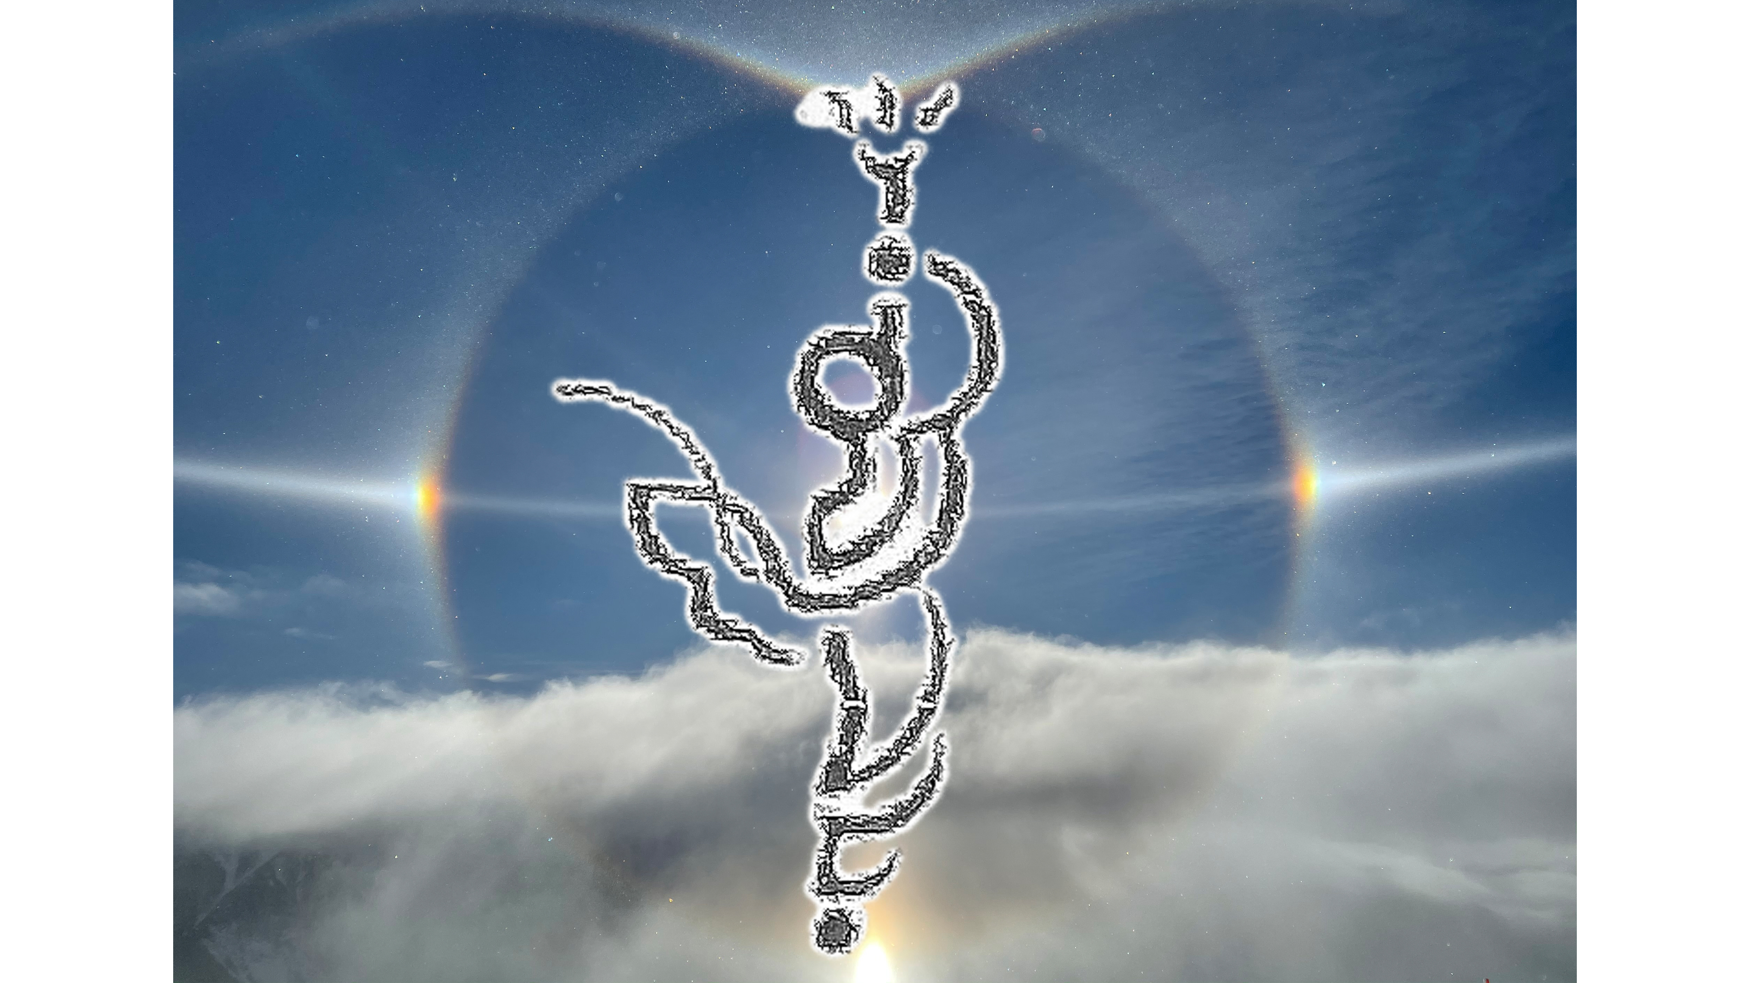  Cost per session adults chf 70 - students chf 35  Inscription: Lorna Barbey 076 822 9769 - lorna.barbey@sunrise.ch  Doris Pulfer 076 463 4446 - shiatsu.pulfer@epost.ch |  | ¨Beyond Words¨  Enjoy a natural and easy dance practice integrating body, mind and emotions.  ¨Nourish the Life inside Us¨  10 January, , 28 February, 28 March 2026  14h00 - 17h00  Verein Nautilus  Bälliz 25  3600 Thun  Lorna Barbey is delighted to share a time to BE in your body, responding to an eclectic range of world music, connecting to self and others so we can feel the vibrant life inside via a journey of revitalisation, relaxation, regeneration,  a change shape - change state enquiry and celebration !  No set steps, no dance experience necessary  Guided movement exercises are proposed  The sessions are non verbal  Cost per session adults chf 70 - students chf 35  Inscription: Lorna Barbey 076 822 9769 - lorna.barbey@sunrise.ch  Doris Pulfer 076 463 4446 - shiatsu.pulfer@epost.ch

